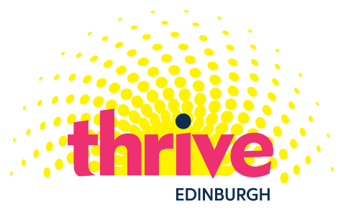
Edinburgh Thrive Arts Programme 2022: Small Grants Application Form

Name of organisation/group
(If applicable)
Name of key contact
Address
Telephone
Email
Title of event/activity
Proposed date(s)
Venue/place/online
Would you like the event/activity to be included in the SMHAF online/printed programme? (4-24 May 2022)
Is the event linked to any other festivals or part of a larger event?
Are you working with any partner agencies for the event?
Describe the activity or event
(This can be a few sentences and up to 200 words)

What is the target group for the event? (Who do you intend will take part?)
How will you evaluate the event?
What is the anticipated legacy? (For example, how do you think you, participants and/or the organisation will benefit from the event?)
Optional:
Any other extra information that will help us to understand this application
(No more than 100 words)

 | Item | Cost
Artist / Facilitator fees
Volunteer costs
Materials
Publicity
Venue hire/refreshments
Other, please specify
Total cost of event/activity
Total amount applied for

- Please read the Grants Information before completing an application
- The deadline for sending applications is midday on Monday 14 February 2022
- Email applications to pam@capsadvocacy.org

Please get in touch with Pam van de Brug at CAPS Independent Advocacy with any questions via email or by phone 07989 402634.

CAPS Independent Advocacy Privacy Notice

We need this information about you to process your grant application. Without this information, we will not be able to consider your grant application. This information will be used by CAPS Independent Advocacy and partners Edinburgh Thrive Arts in our work allocating this funding. If your application is successful, the information you provide in this application will also form part of our funding agreement.

The information, including your name and any other details you have given us will be seen by individuals working for and directly with CAPS Independent Advocacy, including our auditors if required in the fulfilment of our charitable responsibilities and partners Edinburgh Thrive Arts. We’ll keep the information indefinitely.

We may also sometimes have to pass on information if we believe you or another person might be at risk – for more information about this, please ask the member of staff you're working with for a copy of our Confidentiality Policy. We’ll keep the information indefinitely.

You have the following rights about your information:
• the right of access – e.g. to ask for a copy;
• the right to rectification – e.g. to ask us to correct mistakes;
• the right to erasure – e.g. to ask us to destroy it if you tell us you no longer wish to submit artwork;
• the right to restrict processing – e.g. to ask us to stop using it for a period of time if you think we are doing something wrong;
• the right to raise concerns with the Information Commissioner’s Office (ICO) if you think we are doing something wrong. ICO website: ico.org.uk

You can speak to (Pam) about any of these rights, or for more details about how we manage information, please ask her for a copy of our Data Protection policy.

CAPS Independent Advocacy
Old Stables
Eskmills Park
Station Road
MUSSELBURGH
EH21 7PQ
phone: 0131 273 5116
web: www.capsadvocacy.org

CAPS Independent Advocacy is a Scottish Charitable Incorporated Organisation. Scottish Charity number SC021772

