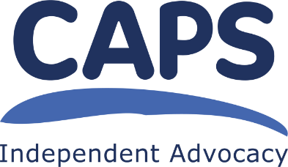
CAPS Independent Advocacy

Collective Advocacy Worker – Oor Mad History

Person Specification

Essential

- Have a good understanding of the issues facing people who are living with mental health issues;

- Have an understanding of Collective Advocacy and what it means to be an Independent Advocacy organisation;

- Have an understanding about working in a trauma informed way and the ability to create trusting relationships with group members;

- Know how to plan, structure, deliver and evaluate training, online and face-to-face;

- Have experience of producing written reports and preparing and delivering verbal reports and presentations, adapting style and language to suit the audience;

- Have experience of facilitating groups in a non-directive and non-judgemental way so people with different experiences within the group can contribute equally and in the way that suits them best;

- Have experience of working independently and completing tasks to agreed timescales – being organised, self-motivated and able to use initiative appropriately;

- IT skills: ability to use Microsoft Office computer packages, including Word and Outlook; experience of using videoconferencing tools.

DESIRABLE
- Know how to manage the archive, with knowledge about data protection, copyright and cataloguing procedures;

- Know how to recognise and address possible conflicts of interest that might arise;

