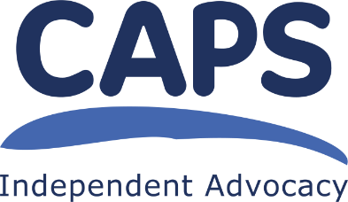
CAPS Independent Advocacy

Collective Advocacy Worker East & Midlothian

Person Specification

Essential

- Have knowledge and understanding of how mental health issues can affect peoples’ lives;

- Have an understanding of Collective Advocacy and what it means to be an Independent Advocacy organisation;

- Have an understanding about working in a trauma informed way and the ability to create trusting relationships with group members;

- Have experience of facilitating groups in a non-directive and non-judgemental way so people with different experiences within the group can contribute equally and in the way that suits them best;

- Have experience of working independently - being self-motivated and able to use initiative appropriately;

- Have excellent organisational skills and be able to plan and prioritise your workload to ensure all tasks are completed taking into account the needs of your colleagues and group members;
- Have experience of producing high quality written reports and delivering verbal reports and presentations, with confidence and compassion to influence decisions to the benefit of the people you are representing;

- IT skills: ability to use Microsoft Office computer packages, including Word, Powerpoint and Outlook; experience of facilitating meetings using video conferencing; experience of using online survey tools;
Desirable

- Have good local knowledge of geography, services and issues affecting both East Lothian and Midlothian;

- Ability to reflect on own practice and gather feedback from the group and colleagues to ensure best possible work performance;

- Experience in facilitating and delivering workshops to diverse groups of people.

- Have a driving licence and use of a car

CAPS is a Scottish Charitable Incorporated Organisation.
Scottish Charity number SC021772 Feb 2023

