CAPS Independent Advocacy 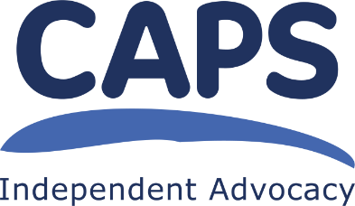

Collective Advocacy Worker – Experiences of Trauma and Minority Ethnic Advocacy

Person Specification

Essential

- Have knowledge and understanding of the issues faced by people from minority ethnic backgrounds in accessing mental health services in Edinburgh;

- Have an understanding of Collective Advocacy and what it means to be an Independent Advocacy organisation;

- Knowledge and understanding about living with the effects of trauma;
- Have an understanding about working in a trauma informed way and the ability to create trusting relationships with group members;

- Have experience of facilitating groups in a non-directive and non-judgemental way so people with different experiences within the group can contribute equally and in the way that suits them best;

- Have experience of working independently and completing tasks to agreed timescales – being self-motivated and able to use initiative appropriately;

- Know how to plan, structure, deliver and evaluate learning sessions incorporating group members’ lived experience;

- Have experience of producing written reports and preparing and delivering verbal reports and presentations, adapting style and language to suit the audience;

- Know how to recognise and address possible conflicts of interest that might arise:

- Experience of reflecting on own practice and gathering feedback from the group and colleagues to ensure best possible work performance;

- IT skills: ability to use Microsoft Office computer packages, including Word, Powerpoint and Outlook; experience of facilitating meetings using video conferencing; experience of using online survey tools;

CAPS is a Scottish Charitable Incorporated Organisation.
Scottish Charity number SC021772 June 2023

