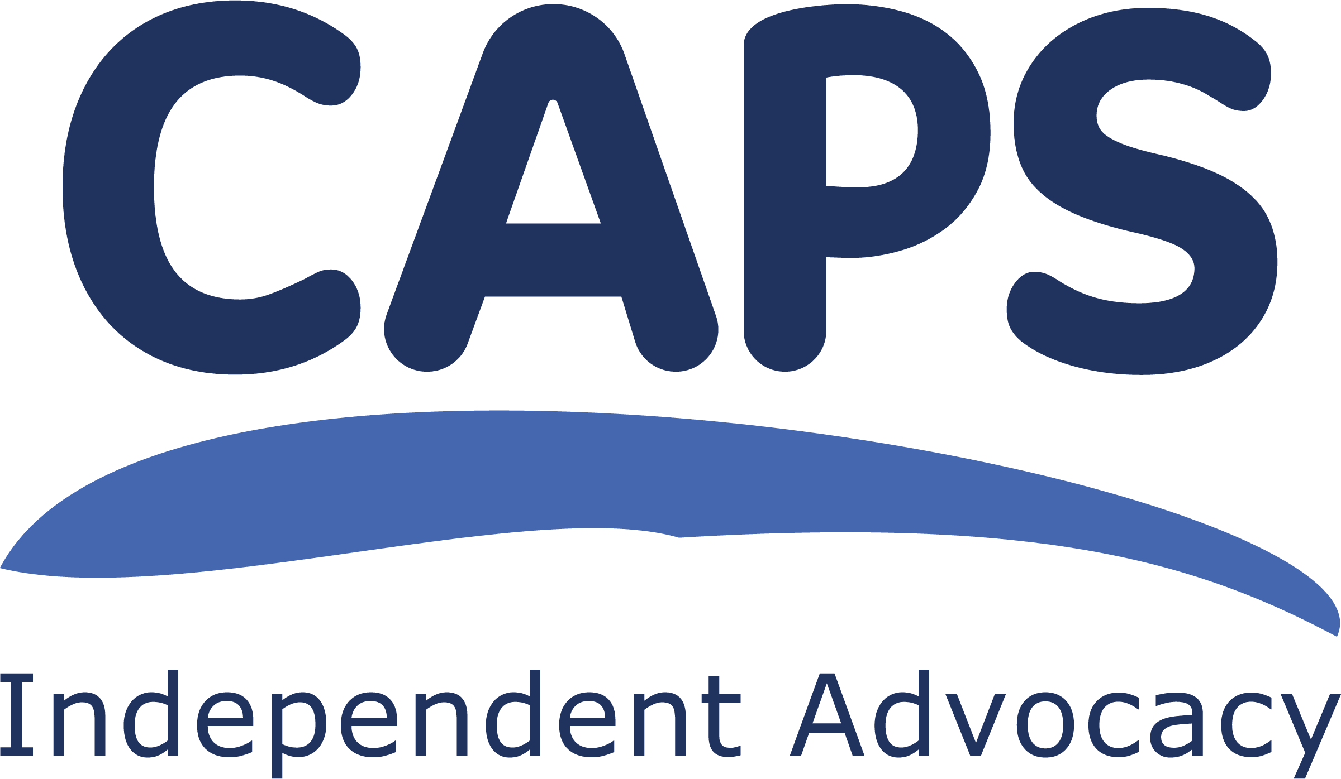
CAPS Independent Advocacy

JOB DESCRIPTION

POST: Collective Advocacy Worker (Veterans)

GEOGRAPHICAL REMIT: Scotland

LOCATION: CAPS office in Edinburgh

HOURS: 36.25 hours per week (FT)

SALARY SCALE: AP4 (point 27 – 30), £ 25,778 - £ 28,533 p.a.

STARTING SALARY: £ 25,778

LINE MANAGER: Collective Advocacy Manager

GENERAL PURPOSE OF POST

The main purpose of this post is to provide Collective Advocacy for Veterans. A veteran is someone who served in the active military, naval, or air service for at least one day (Regular or Reserve) or Merchant Mariners who have seen duty on legally defined military operations. Collective advocacy will enable the voices and views of veterans to be embedded in the work of the Scotland’s Veterans Wellbeing Alliance’s new strategy, ‘New frontiers’, and their 4 strategic aims by feeding in through their Veterans Advisory Board.

The Scotland’s Veterans’ Wellbeing Alliance (SVWA) provides spaces and places across Scotland where veterans and families can connect, receive and provide support, learn new skills and benefit from activities delivered by a compassionate workforce striving to nurture relationships with all who have an interest in veterans’ health and wellbeing.
This Alliance is funded by the Armed Forces Covenant - Veterans’ Places, Pathways and People grant programme and brings together funded partners across the whole of Scotland who will provide a diverse range of services and support to veterans and their families.

The post holder will be based in Edinburgh and will make connections with veterans across all of Scotland, in person and remotely. There are 220,000 veterans living in Scotland.

The Collective Advocacy Worker will make SVWA documents, reports and information accessible to people and assist them to understand and respond to, requests for their views on the activities of the Alliance. They will respond to the needs and wishes of the veterans involved and may help them challenge or campaign on topics which are of interest or concern to them. The post will also involve raising awareness of the experiences of veterans to improve the services offered by the Alliance and to educate the public more widely about what it is like to serve in the Armed Forces.

The post-holder will liaise directly with veterans, service staff from Alliance partners and other SVWA governance groups.

TASKS
- make contact and engage with veterans across all of Scotland and build upon existing relationships;

- organise and facilitate meetings with groups and individuals across Scotland, at times and locations that work for them. These may be online or in person;

- facilitate collective advocacy groups which will contribute directly to the governance of the SVWA;

- help veterans get as much information as they want/need to make informed choices and understand their rights within the Alliance;

- use a variety of methods to help veterans to share and discuss what’s important to them;

- help veterans take forward the work they have identified as important;

- represent the expressed views and interests of veterans at Alliance meetings where no individuals or representatives can attend;

- as directed by the veterans involved, contact and consult with other relevant groups e.g. workers, planners of services, etc;

- distribute publicity about the new veterans’ collective advocacy project;

- use IT to prepare reports, promotional material, and to gather information, and use databases to manage communication within and outwith the project, adhering to GDPR procedures;

- report on agreed targets: recording, monitoring, reviewing and evaluating the work done;

- prepare and give presentations;

- support veterans to play an active part in the development of the Alliance and to develop it to include services that meet their needs;

General tasks

- work independently, prioritise workload and meet deadlines;

- work alongside other Collective Advocacy staff as required as part of the CAPS staff team and contribute to the smooth running of the office;

- have a commitment to and ensure the practical application of CAPS’ policies and procedures;

- be aware of boundaries in all the relationships established in carrying out this work;

- ensure that your actions and work behaviours meet the standards set by CAPS;

- ensure all your work behaviours display an anti-racism approach and challenge any prejudice and discrimination shown to people with protected characteristics.

- any other duties deemed relevant to the post.

CONTACTS

- Veterans and other members of the public;

- Policy makers, planners and decision makers;

- Service providers;

- Service staff who are members of the SVWA;

- staff from other advocacy organisations;

- other CAPS’ staff, volunteers, Management Committee members.

MANAGEMENT
You will be line managed by the Collective Advocacy Manager. You will be ultimately accountable to the Management Committee and will be expected to report to them when required. You will also take part in team meetings with other CAPS’ staff.

LOCATION
This post is based in CAPS’ office in Edinburgh. However, you will be expected to travel extensively throughout Scotland. In work travel expenses will be reimbursed. Some home working will be permitted.

FUNDING
This post is funded by the Scottish Veterans Wellbeing Alliance for an initial fixed term of 12 months until 31 March 2026. It will continue thereafter subject to continued funding.

EMPLOYER
Your employer will be CAPS’ Management Committee.

TRAINING
You will be expected to participate in training and personal development as identified through supervision with your line manager. You may also ask for particular pieces of training. It may not be possible to approve a particular piece of training if we do not have the resources.

WORKING HOURS

Your working hours will be 36.25 hours per week (full time) worked over 5 days. Some evening or weekend work is possible and if required, would be accommodated into the contractual hours.

HOLIDAYS

30 days annual leave plus 5 fixed and 6 floating public holidays.

ABOUT CAPS
CAPS is an Independent Advocacy Organisation which provides Individual Advocacy to adults from East Lothian and Midlothian who have mental health issues, are using drugs and alcohol, or who are members of the LGBTQIA+ community. We also provide individual advocacy for children and young people going through the Children’s Hearings process in these areas.
We provide Collective Advocacy to groups of people across Lothian with mental health issues so they can come together and voice their experiences in order to bring about change for others or improvements in services.

The main purpose of CAPS’ work is therefore to assist people, through advocacy, as individuals or as members of a group, to set their own agenda, make their wishes known and to have a say in how they live and what services they use. Visit our website for more details www.capsadvocacy.org

We are set up so that the organisation and its staff are as free as possible from any conflicts of interest. We are independent from the people who fund us and those who provide other services to the people we work with. CAPS is a member of the Scottish Independent Advocacy Alliance (SIAA) and we adhere to the Principles and Standards of Independent Advocacy. CAPS was established in 1991.

CAPS’ main office is in Musselburgh, East Lothian.

MISCELLANEOUS
For the good of CAPS, all staff have a duty to be flexible enough in their working practice to support the work of other functions within the organisation.

This post will be subject to membership of the Protecting Vulnerable Groups Scheme (PVG Scheme) and appropriate check.

CAPS is a Scottish Charitable Incorporated Organisation.
Scottish Charity number SC021772

January 2025 ED

